Step 1:
Open the project:
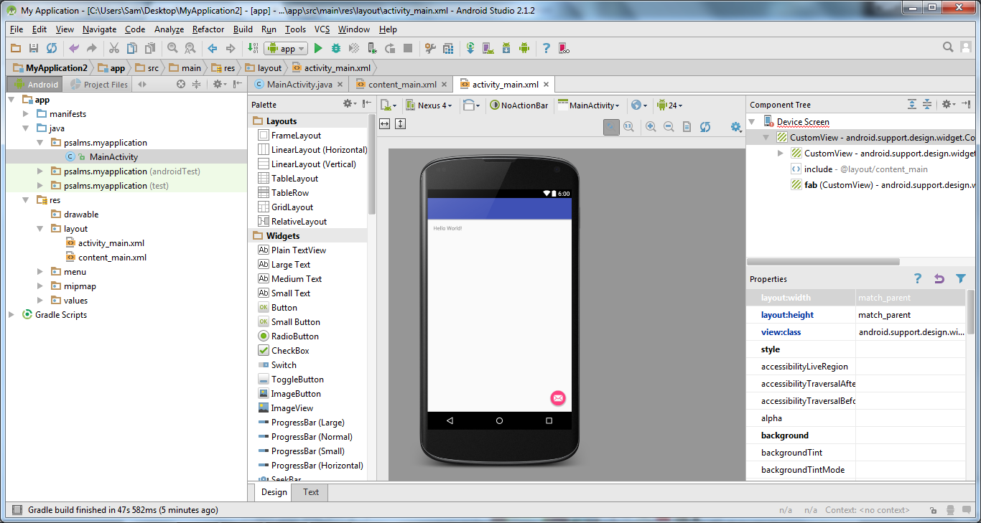

Step 2:
Create an emulator: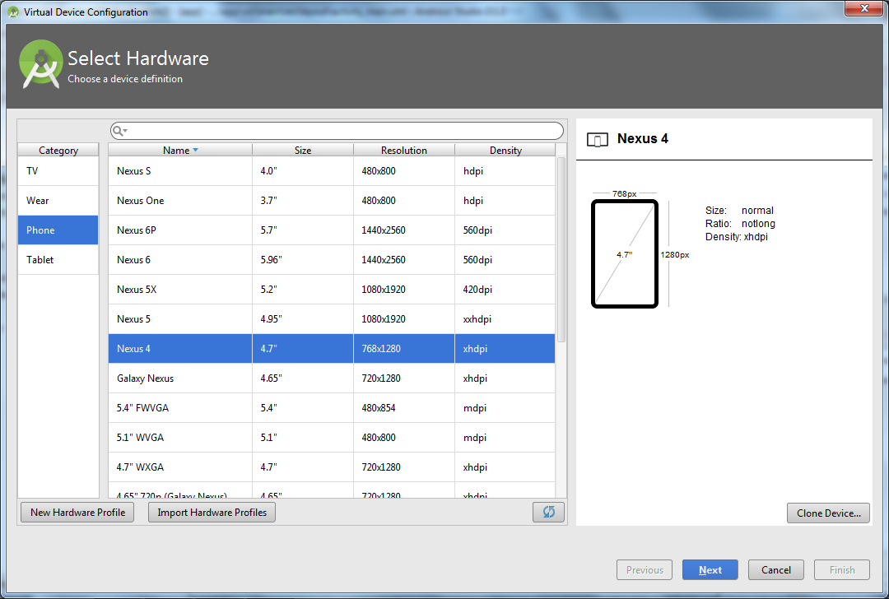

Step 3:
After Creating the emulator select deployment target:
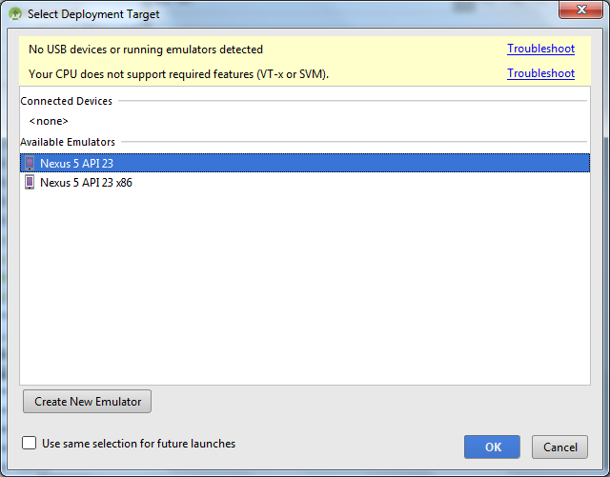

Step 4:
Open the app in the avd emulator:
